Lab 5; Verification of Series and Parallel Resonance Circuits

Jake D. Karas

U0000008780

EEL3112C: Circuits 2

8/11/2022

**Objectives:**

The goal of this experiment was to verify that the maximum output of a resonant AC circuit occurs at resonance. This occurs when the input frequency is at a special value, known as the resonant frequency ($ω_{0}$). At this point, the frequency response of a series RLC circuit’s current magnitude or a parallel RLC’s voltage magnitude is at its peak amplitude.

**Equipment:**

* Resistor x3
 $1 Ω (1.224 Ω)$

 $10 Ω (11.9 Ω)$

+ Shunt: $1 Ω (1.7 Ω)$
* Inductor x2
$100 μH (99.78620 μH)$

$1 mH (971.0963 μH)$

* Capacitor x2
$100 μF (98.61 μF)$

$1 mF (945.5 μF)$

* AC Voltage Source (Function Generator)
* Voltmeter (Oscilloscope)
* Ammeter (Multimeter)

**Theory Development:**

When an RLC circuit’s capacitive and inductive reactances achieve an equivalent magnitude, no matter the formation of its components, the power output is at its maximum for the circuit. For a series RLC circuit, the input impedance is $Z=R+j(ωL-\frac{1}{ωC})$. As such, resonance occurs once $ωL-\frac{1}{ωC}$, the imaginary component of the impedance, is zero. When set equal to the angular frequency, it is found that $ω=\frac{1}{\sqrt{LC}}$, and this can be converted to frequency by dividing by $2π$. In a similar manner, the input admittance of a parallel RLC circuit is $\frac{1}{Z}=\frac{1}{R}-j(\frac{1}{ωL}-ωC)$. Setting the reactive component to zero and solving for $ω$ once more yields $ω=\frac{1}{\sqrt{LC}}$.

With the impedance being purely resistive, the maximum power dissipation occurs at resonance. As such, the maximum current through a series RLC circuit can be calculated by setting the angular frequency to the resonant frequency and using it in the current-frequency response formula $I=|I|=\frac{V_{m}}{\sqrt{R^{2}+(ωL-\frac{1}{ωC})^{2}}}$. Similarly, the maximum voltage through a parallel RLC circuit is found by doing the same as above, but for the voltage-frequency response formula, $V=|V|=\frac{I_{m}}{\sqrt{R^{2}+(\frac{1}{ωL}-ωC)^{2}}}$.

**Methods/Procedures:**

After constructing one of the two RLC circuits, the multimeter was inserted in the proper manner for the measurement type being taken for each of the two circuits. As such, in the series circuit, it was placed in series for current measurements, whereas in the parallel circuit, it was across the 4th line $1 Ω$ shunt resistor. With the input voltage being a 5 volt peak sinusoid, the frequency of this signal was adjusted from low to high, recording the proper measurement for each circuit type at certain frequencies, including the resonant frequency.

**Circuit Diagrams:**

Series:

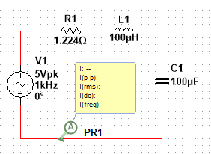

Parallel:

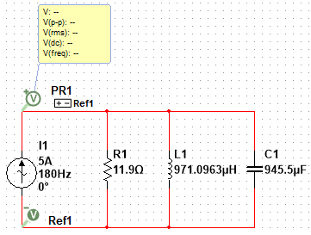

**Results (Theoretical and Experimental):**

Series Circuit:

* Resonance Values:

$ω_{0}=10000 rad/s$

$f_{0}=1591.5 Hz$

$Q=1$

$B=10000 rad/s$

$ω_{1}=6180.3 rad/s$

$f_{1}=983.6 Hz$

$ω_{2}=16180.3 rad/s$

$f_{2}=2575.2 Hz$

$I_{ω}=|I|=\frac{5}{\sqrt{1.224^{2}+({0.00009978620ω-\frac{1}{0.00009861ω})}^{2}}} A$

$I_{f}=\frac{5}{\sqrt{1.224^{2}+(2π*{0.00009978620ω-\frac{1}{2π*0.00009861ω})}^{2}}} A$

| Theoretical | |
| --- | --- |
| $f (Hz)$ | $I (A rms)$ |
| $7$ | $21.686 m$ |
| $10$ | $30.980 m$ |
| $50$ | $0.155$ |
| $500$ | $1.582$ |
| $983.6$ | $3.133$ |
| $1500$ | $4.060$ |
| $1591.5$ | $4.0846$ |
| $1600$ | $4.0849$ |
| $2000$ | $3.837$ |
| $50 k$ | $0.160$ |
| $100 k$ | $79.753 m$ |
| $200 k$ | $39.875 m$ |
| $500 k$ | $15.950 m$ |

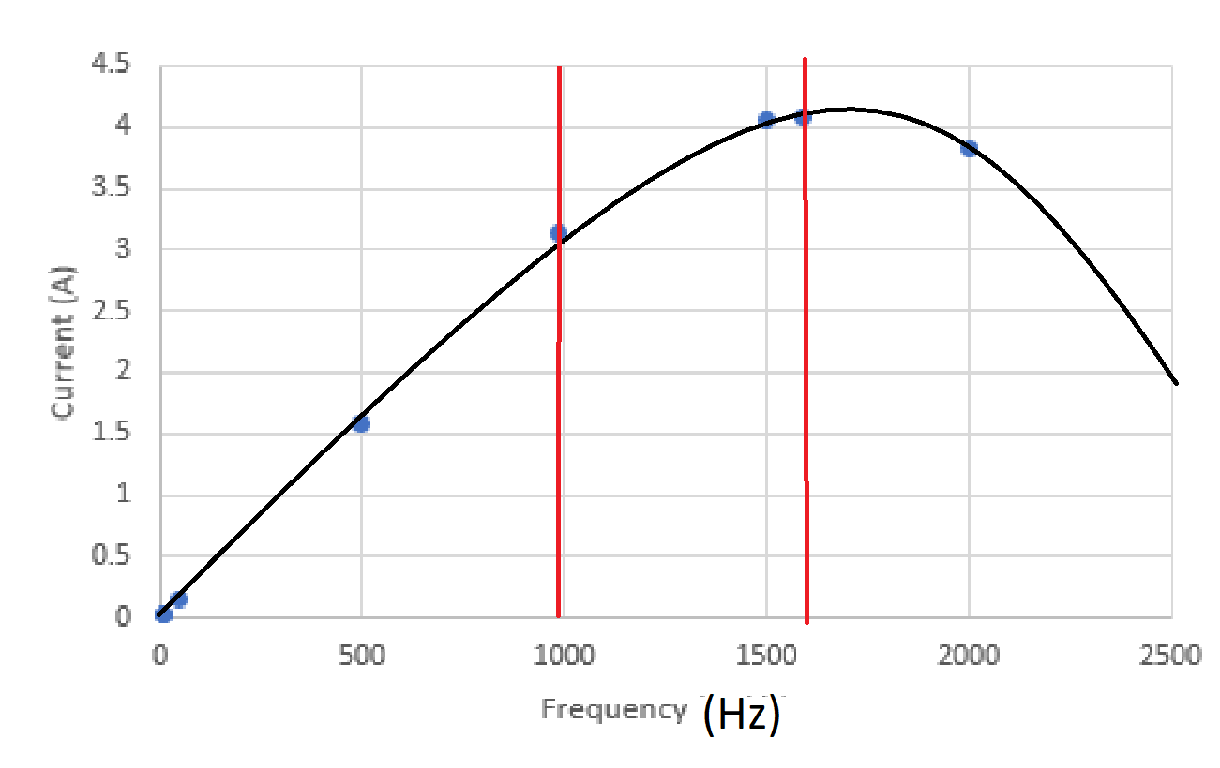

| Experimental (Multisim) | |
| --- | --- |
| $f (Hz)$ | $I (A rms)$ |
| $7$ | $15.6 m$ |
| $10$ | $22.3 m$ |
| $50$ | $0.111$ |
| $500$ | $1.14$ |
| $983.6$ | $2.24$ |
| $1500$ | $2.88$ |
| $1591.5$ | $2.89$ |
| $1600$ | $2.89$ |
| $2000$ | $2.70$ |
| $50 k$ | $0.112$ |
| $100 k$ | $56.1 m$ |
| $200 k$ | $28.0 m$ |
| $500 k$ | $11.2 m$ |

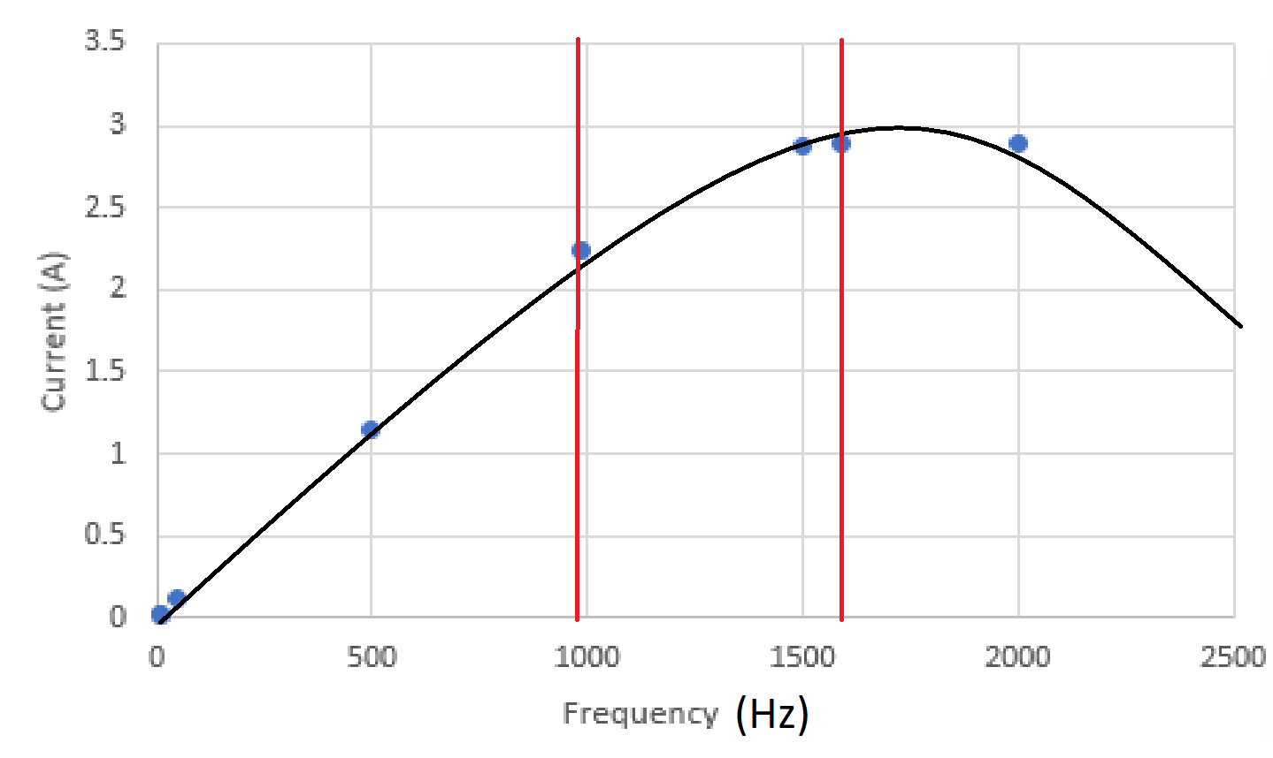

| Experimental (Hardware) | |
| --- | --- |
| $f (Hz)$ | $I (mA rms)$ |
| $7$ | $3.65$ |
| $10$ | $5.48$ |
| $50$ | $15.90$ |
| $500$ | $18.57$ |
| $983.6$ | $19.06$ |
| $1500$ | $19.21$ |
| $1591.5$ | $19.24$ |
| $1600$ | $19.23$ |
| $2000$ | $18.69$ |
| $50 k$ | $16.75$ |
| $100 k$ | $12.90$ |
| $200 k$ | $8.38$ |
| $500 k$ | $3.85$ |

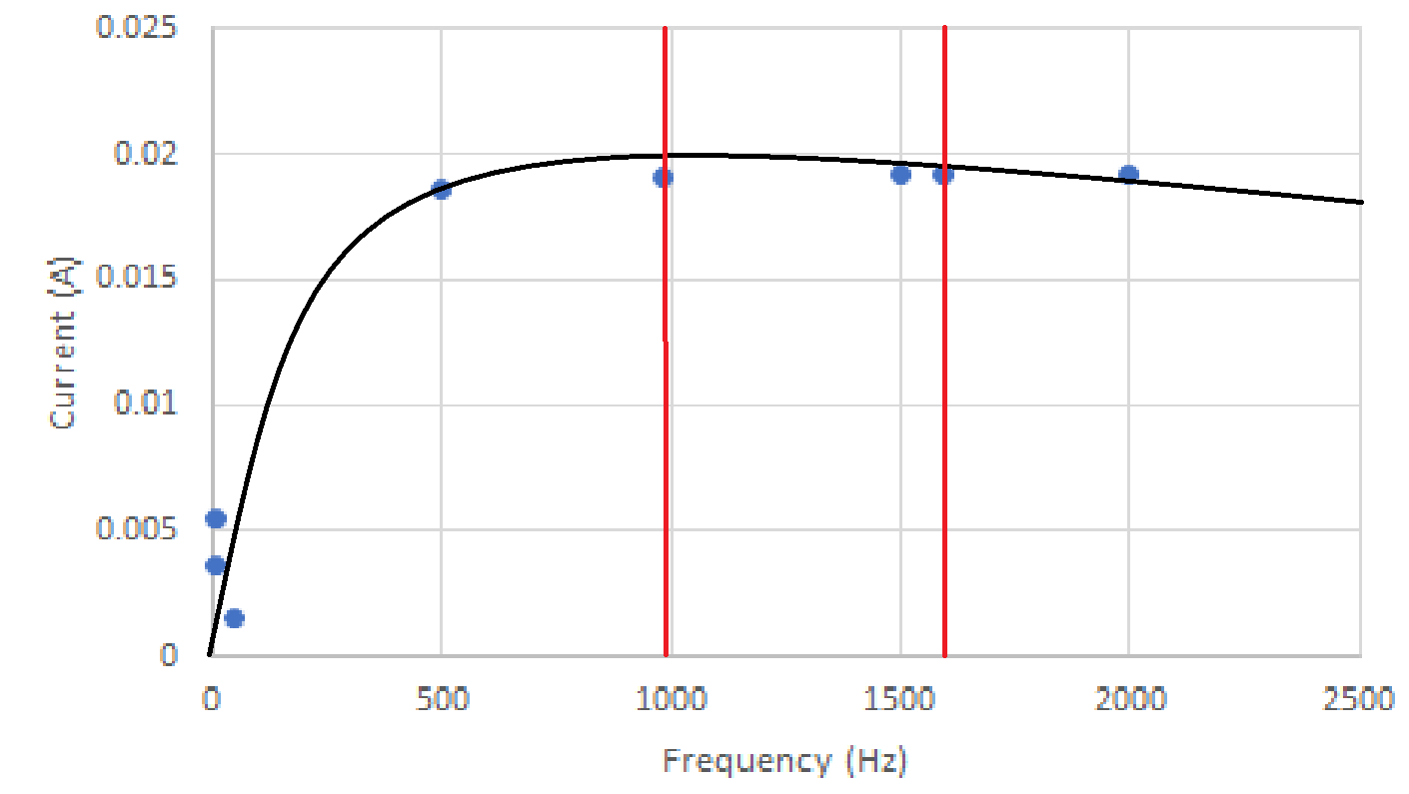

Parallel Circuit:

* Resonance Values:

$ω_{0}=1000 rad/s$

$f_{0}=159.155 Hz$

$Q=10$

$B=100 rad/s$

$ω_{1}=951.249 rad/s$

$f_{1}=151.396 Hz$

$ω_{2}=1051.249 rad/s$

$f_{2}=167.312 Hz$

$V_{ω}=|V|=\frac{5}{\frac{1}{11.9^{2}}+({\frac{1}{0.0009710963ω}-0.0009455ω)}^{2}}$

$V_{f}=\frac{5}{\frac{1}{11.9^{2}}+({\frac{1}{2π*0.0009710963ω}-2π*0.0009455ω)}^{2}}$

| Theoretical | | |
| --- | --- | --- |
| $f (Hz)$ | $V (V pk)$ | $V (V rms)$ |
| $50$ | $1.677$ | $1.186$ |
| $70$ | $2.594$ | $1.834$ |
| $100$ | $4.770$ | $3.373$ |
| $120$ | $7.596$ | $5.371$ |
| $159.2$ | $42.155$ | $29.808$ |
| $180$ | $27.826$ | $19.676$ |
| $210$ | $10.535$ | $7.449$ |
| $240$ | $6.688$ | $4.729$ |
| $270$ | $4.997$ | $3.533$ |

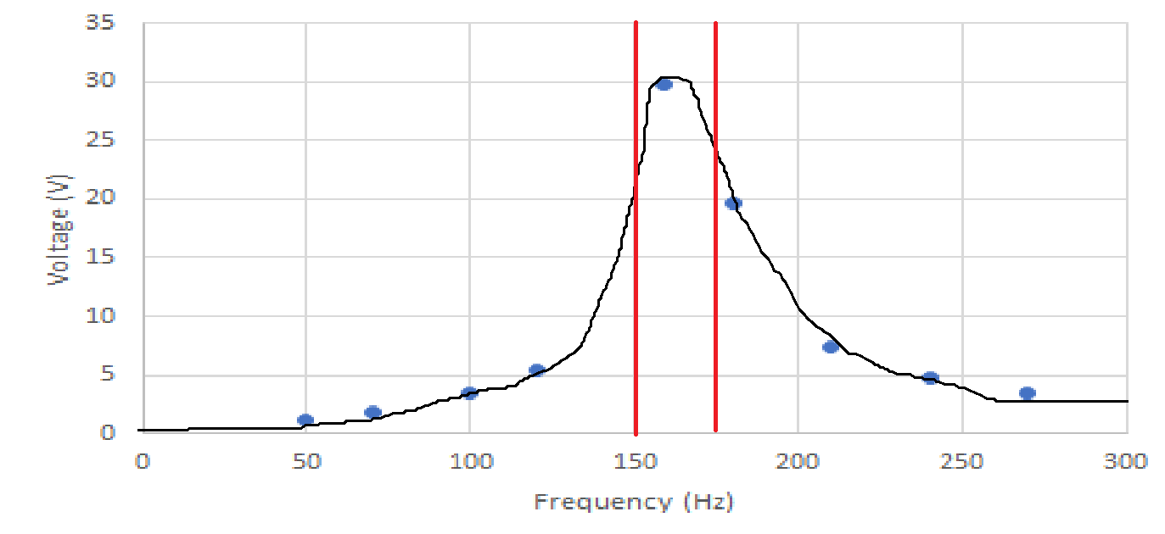

| Experimental (Multisim) | | |
| --- | --- | --- |
| $f (Hz)$ | $V (V pk)$ | $V (V rms)$ |
| $50$ | $3.36$ | $1.19$ |
| $70$ | $5.20$ | $1.84$ |
| $100$ | $9.59$ | $3.40$ |
| $120$ | $15.3$ | $5.43$ |
| $159.2$ | $87.2$ | $31.0$ |
| $180$ | $54.0$ | $19.1$ |
| $210$ | $20.7$ | $7.35$ |
| $240$ | $13.2$ | $4.69$ |
| $270$ | $9.92$ | $3.51$ |

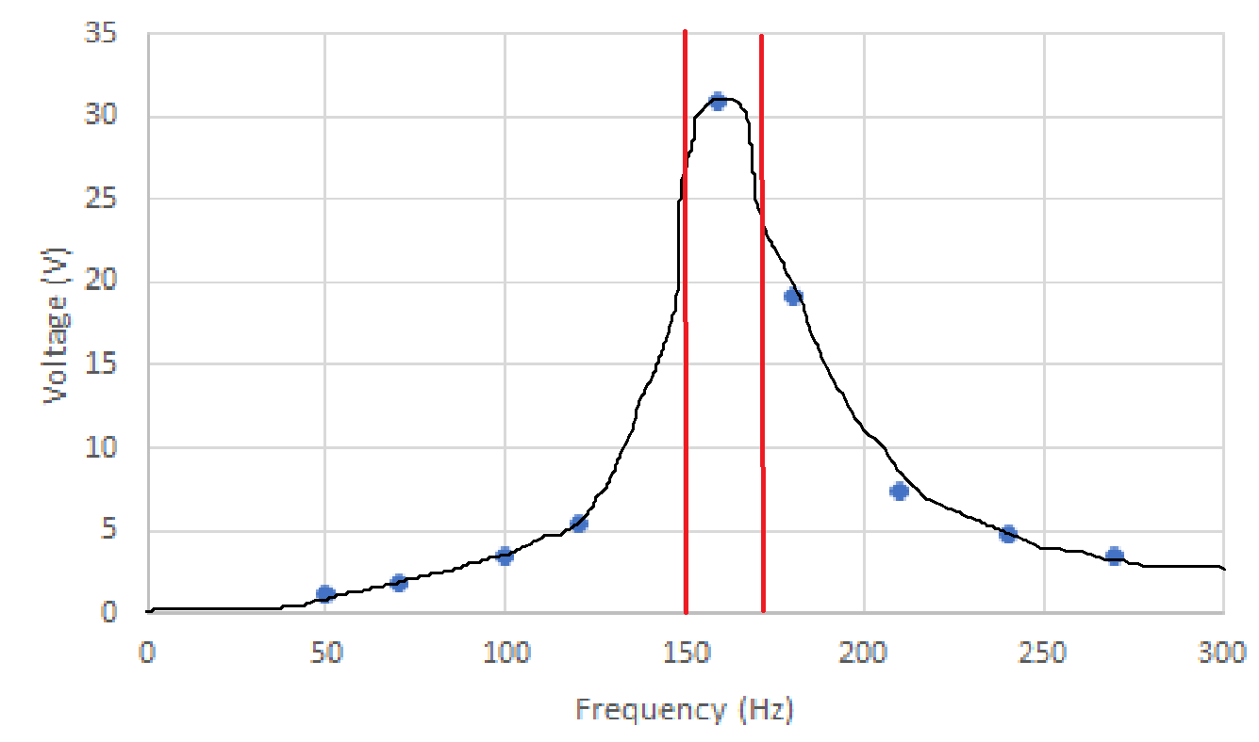

| Experimental (Hardware) | | |
| --- | --- | --- |
| $f (Hz)$ | $V (mV pk)$ | $V (mV rms)$ |
| $50$ | $232$ | $74.5$ |
| $70$ | $236$ | $75.1$ |
| $100$ | $240$ | $77.9$ |
| $120$ | $244$ | $78.8$ |
| $159.2$ | $248$ | $79.7$ |
| $180$ | $240$ | $78.9$ |
| $210$ | $228$ | $72.6$ |
| $240$ | $216$ | $71.5$ |
| $270$ | $212$ | $66.5$ |

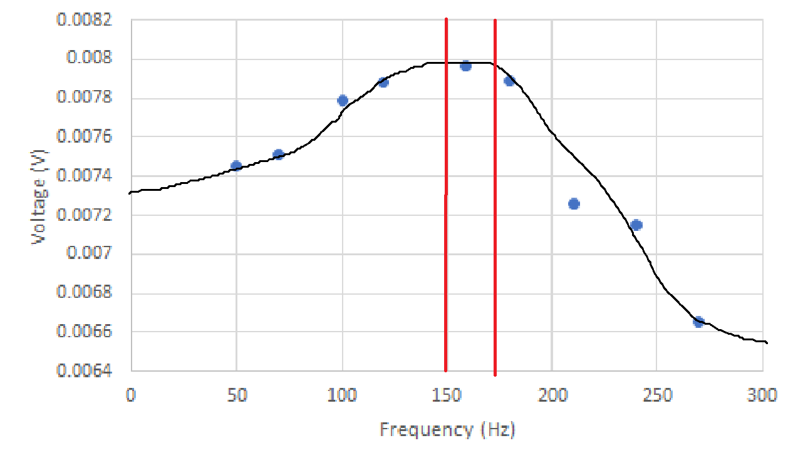

**Results Analysis and Discussion:**

While the theoretical and simulated currents and voltages were relatively similar for the two circuits respectively, the same cannot be said about the actual values. In fact, the magnitudes of these values were all much lower than that of the calculated and simulated values. This was likely due to two faulties involving the multimeter. Firstly, the measurement range of the meter was likely incapable of measuring such high voltages in AC. Secondly, the device itself may have had a high internal resistance. If not the multimeter, then the extreme error may have been caused by utilizing the load impedance of the function generator to maintain the same apparent voltage when taking measurements.

**Conclusion:**

Resonance is an important characteristic of RLC circuits, as it can be used to find the maximum power output of said circuits. This serves as the basis for passive filters of all types, which permit signals of certain frequencies while blocking others. Radios and communication devices utilize resonance in such manner, although some are now made as active filters with additional components other than resistors, inductors, and capacitors.

Reference: <https://www.electronics-lab.com/article/parallel-rlc-circuit-analysis/>